

Memorandum

Date: | July 30, 2025
To: | Craig McDonald – City of Loves Park
From: | Margaret Trowbridge, Seth Gronewold, and Karoline Qasem – Fehr Graham  Engineering & Environmental
Subject: | Loves Park Limited Water Main Replacement Master Plan

INTRODUCTION
This memorandum summarizes the results of the 2025 Limited Water Main Replacement Master Plan for the City of Loves Park. The study evaluated the condition and replacement needs of the City’s water distribution system, using existing GIS and WaterGEMS modeling data provided by the City of Loves Park to prioritize main replacement based on break history, pipe age, material, and size. A weighted scoring system was developed to rank water mains and support data-driven decision- making. The study's findings were shared with City staff via email correspondence. These results are intended to guide the City in developing an annual water main replacement program that is both cost- effective and aligned with system needs.

BACKGROUND
The Loves Park Water Department is responsible for delivering safe and reliable water to approximately 23,000 residents across the City (Figure 1-1). Considering the potential challenges posed by the aging water distribution system, the City initiated the development of a limited Water Main Replacement Prioritization Plan (Plan). This plan aims to address high-risk water mains within the 130-mile distribution network, preventing failures, reducing emergency repair costs, and ensuring a continuous and reliable water supply.
The primary goal of this Plan is to provide a data-driven strategy for proactive replacement of aging, high-risk water mains within the City. This strategy includes a detailed review of the water district’s Geographic Information System (GIS) data. In this context, ‘high-risk’ mains are identified based on their documented history of frequent breaks, critical size affecting capacity or severity of failure, material susceptibility to degradation, and advanced age. By prioritizing these mains, the plan aims to first address the sections of the network that pose the greatest threat to system integrity and service reliability.

July 30, 2025
Loves Park Limited Water Main Replacement Master Plan Page 2

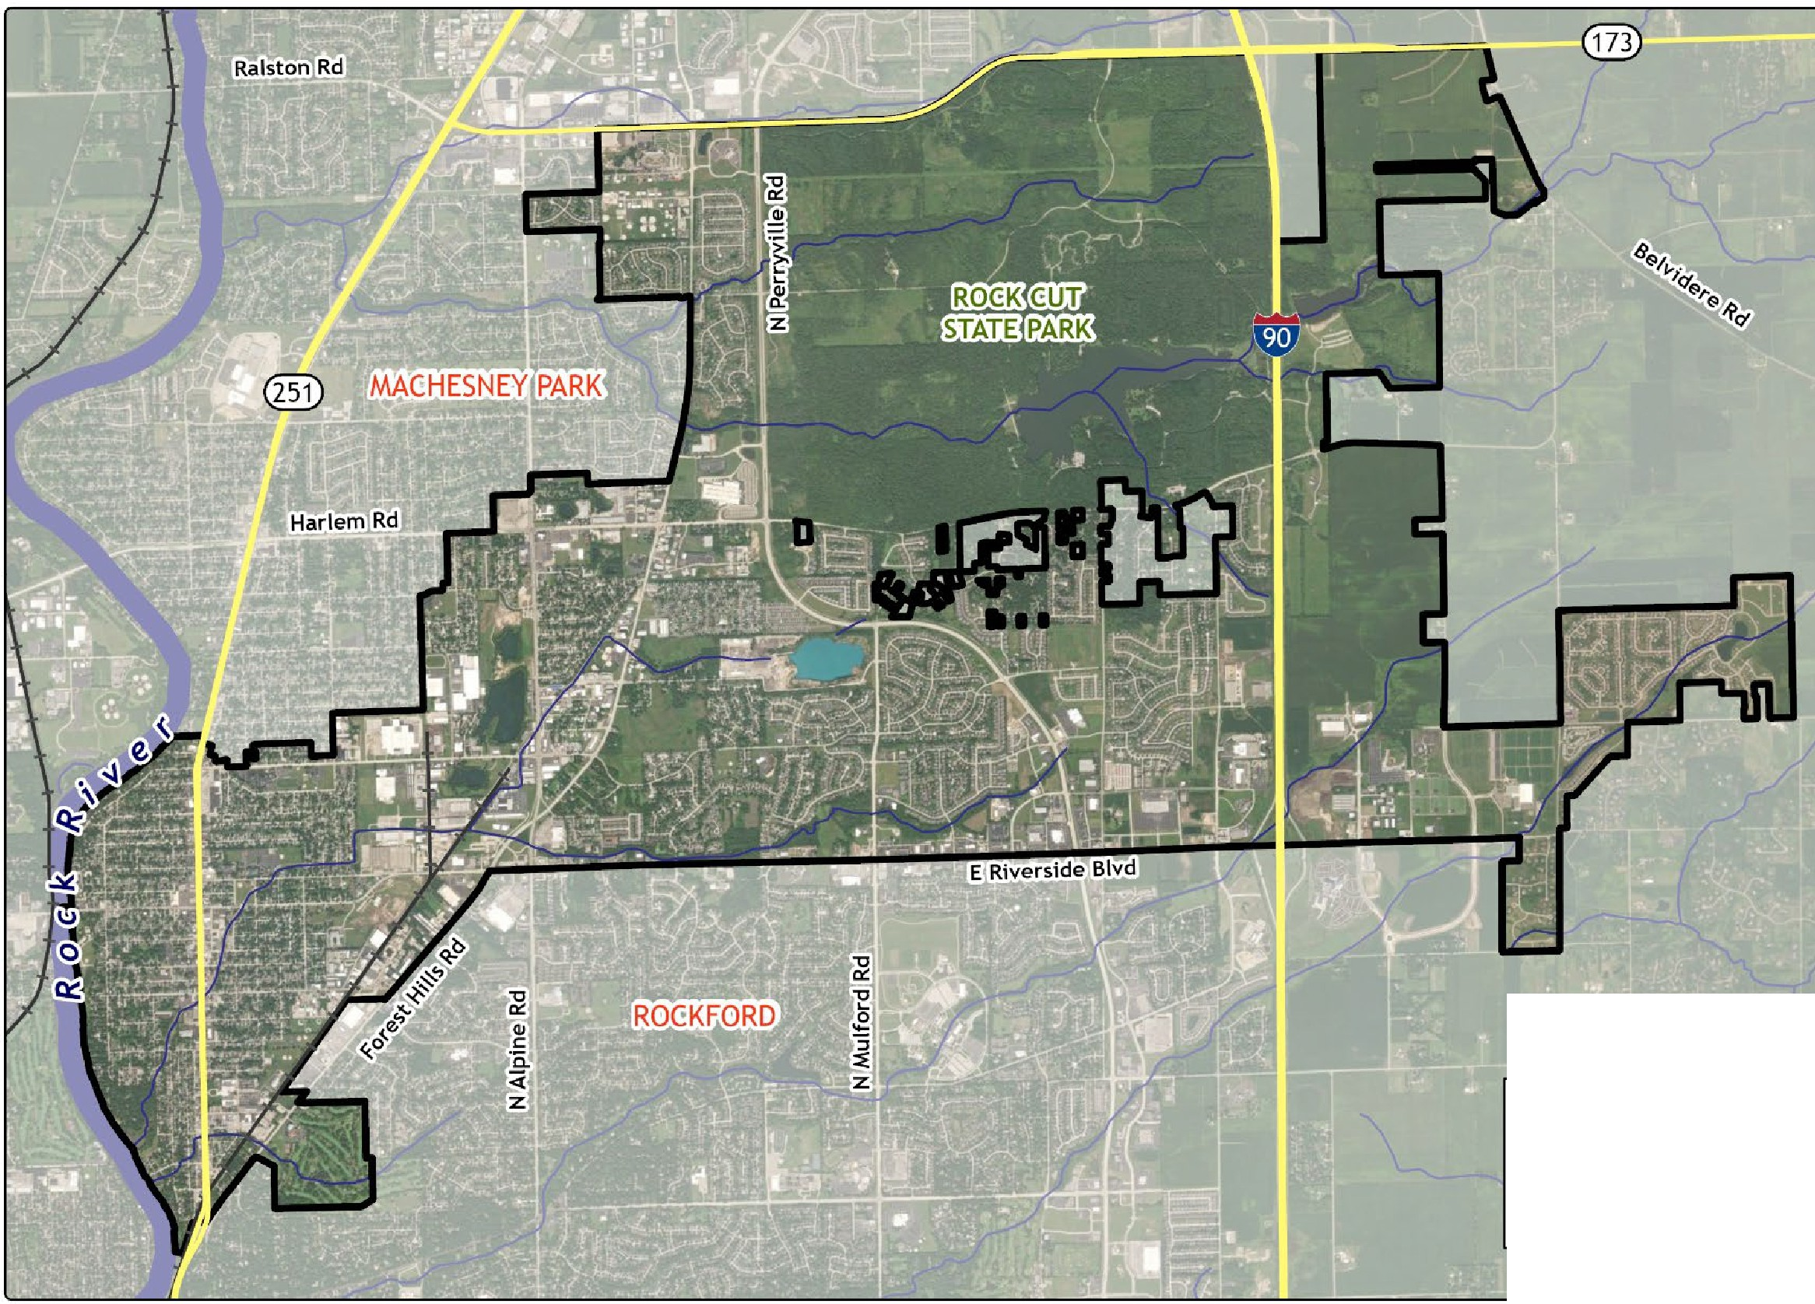
c::::::I City Limits
Highways
-- NHDPlus• Flow Lines
-+- Railroads
"National Hydrograpt,y Dataset Plus
Figure 1-1: Loves Park Service Area

METHODOLOGY
Data Acquisition and Sources
The success of the Plan hinges on the quality and comprehensiveness of the data collected. For this project, the City provided two main datasets: a WaterGEMS model of the City’s distribution system and an Excel spreadsheet detailing the break history.

To prepare the final GIS exhibits, additional data were downloaded from external sources, including the
U.S. Environmental Protection Agency (EPA), Illinois Department of Transportation (IDOT), U.S. Census Bureau, and the Winnebago County Geographic Information System (WinGIS). These datasets were clipped and reprojected to the North American Datum 1983 (NAD 1983) Illinois State Plane West (US Feet) coordinate system to ensure consistency and accuracy in the analysis.
Prioritization Criteria
A scoring system was developed to prioritize water main replacement within the City. This system is based on four key variables: break history, age, material, and size for each water main. The variables were weighted according to their importance and based on a discussion with the Loves Park Water Superintendent at the project kickoff meeting on July 2, 2025, ensuring that the system reflects a balanced and effective approach to identifying high-risk water mains. Within the scoring system, break history was assigned the highest weight of 40% as mains that have failed in the past are likely to fail again soon. Age was weighted at 30%, recognizing that mains deteriorate with age. Material was weighted at 20%, reflecting its importance in durability and maintenance. Size was given the lowest weight of 10% (Table 2-1).

Table 2-1: Scoring Weights for Water Main Replacement Prioritization
Variable | Weight
Break History | 40%
Age | 30%
Material | 20%
Size | 10%
Total | 100%

Break History
According to the collected water main break history data from 2000 onwards, 902 instances of water main breaks have been recorded, indicating situations where water mains failed due to age, material degradation, or external pressure.

Figure 2-1 shows a high concentration of breaks west of Brown’s Parkway and in the residential neighborhoods near the Harlem Hills Nature Preserve. This suggests potential vulnerability in the water main network, possibly related to older infrastructure and higher activity.
Water main break history was weighted at 40%, as mains that have previously failed are likely to fail again. The scoring criteria for each water main are summarized in Table 2-2 below. A score of ‘6’ was assigned to water mains with greater than six breaks, indicating the urgency of replacing them first. A score of ‘0’ was assigned to water mains with no reported breaks. A main with a history of six or more breaks indicates considerable deterioration, and further subdividing this category was not deemed beneficial.

Table 2-2: Break History Prioritization Scoring – Weighted 40%
Number of Breaks | Length (miles) | Percentage of Total System | Score
≥ 6 | 2.0 | 1.5% | 6
5 | 1.2 | 0.9% | 5
4 | 2.4 | 1.9% | 4
3 | 5.1 | 3.9% | 3
2 | 8.1 | 6.2% | 2
1 | 14.1 | 10.9% | 1
0 | 97.4 | 74.8% | 0

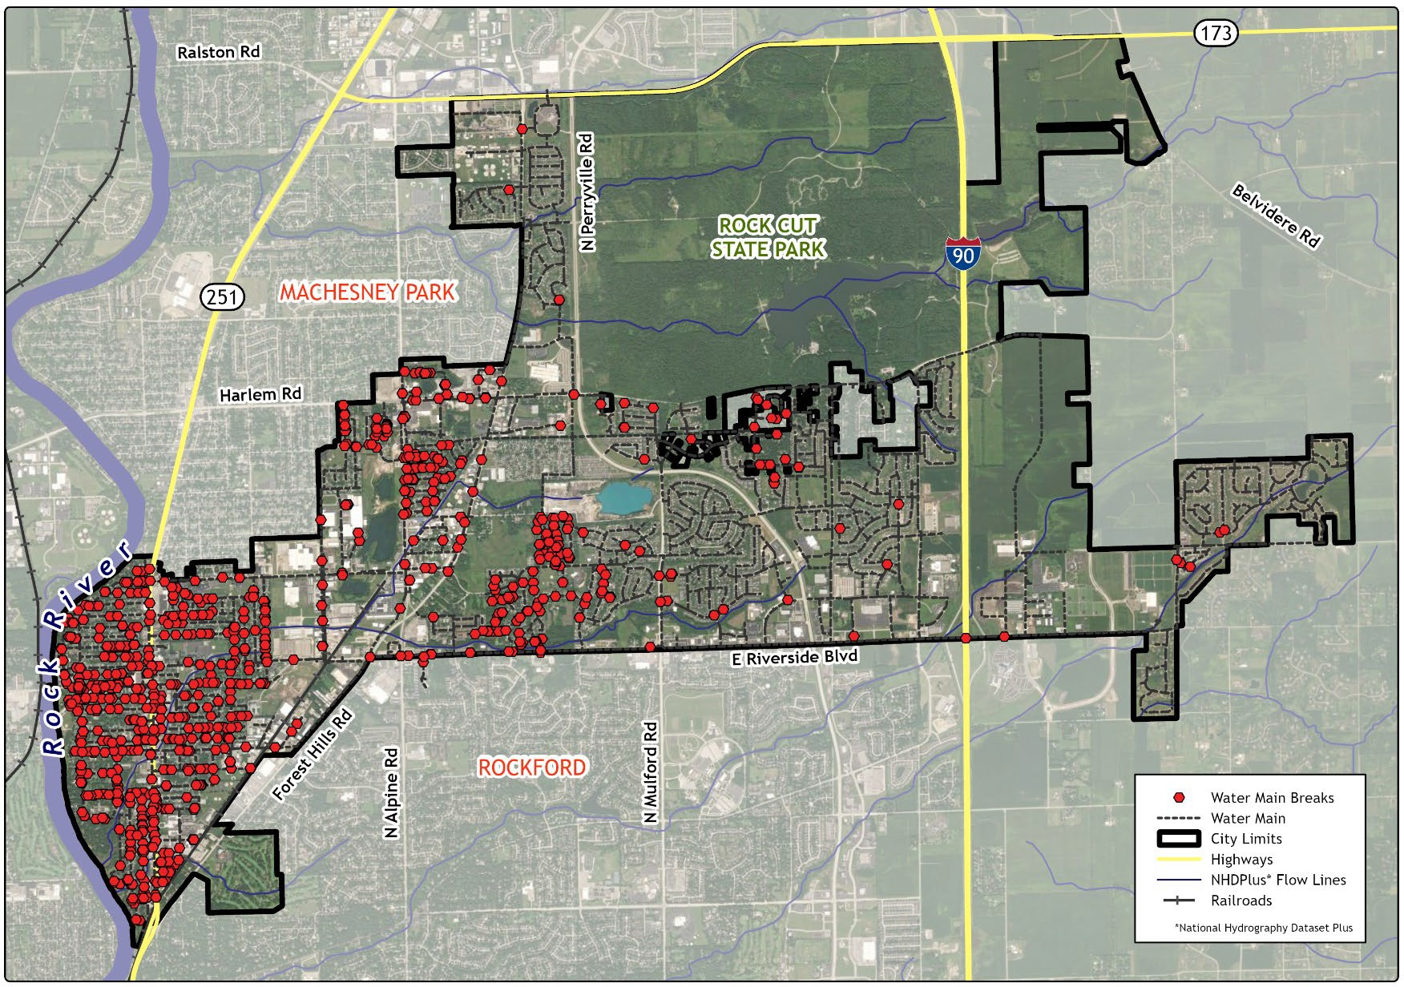
Figure 2-1: Water Main Break History

Age
Loves Park’s water main system spans several decades, with each era reflecting varying needs for maintenance and replacement. About 20% of the water mains were installed in the 1950s and are nearing the end of their service life. The 1960s and 1970s contributed 7% and 13%, respectively, indicating the need for upcoming refurbishment. Water mains from the 1980s represent 18%, and those from the 1990s account for 21%, both of which are approaching critical ages for evaluation. The 17% installed in the 2000s is still relatively functional but aging. Recent installations from the 2010s and 2020s comprise 2% and 3%, respectively, indicating minimal recent replacements and expansions. This distribution highlights the necessity for prioritized replacements, especially for the oldest segments, to maintain reliable service (Table 2-3 and Figure 2-2).
The majority of the features only had an installation decade listed, so installation years were categorized by decades from the 1950s through the 2020s. The water main age factor was weighted at 30%, indicating a relatively moderate impact on the water main replacement prioritization. The scores incrementally increase by 1 point for each preceding decade, reflecting increasing urgency with age. This method ensures older water mains are replaced earlier, taking into account their shorter remaining useful life.

Table 2-3: Age Prioritization Scoring – Weighted 30%
Installation Decade | Length (miles) | Percentage of Total System | Score
1950s | 26.2 | 20.1% | 7
1960s | 9.6 | 7.4% | 6
1970s | 16.3 | 12.5% | 5
1980s | 23.0 | 17.7% | 4
1990s | 27.3 | 21.0% | 3
2000s | 21.7 | 16.6% | 2
2010s | 2.7 | 2.1% | 1
2020s | 3.5 | 2.7% | 0

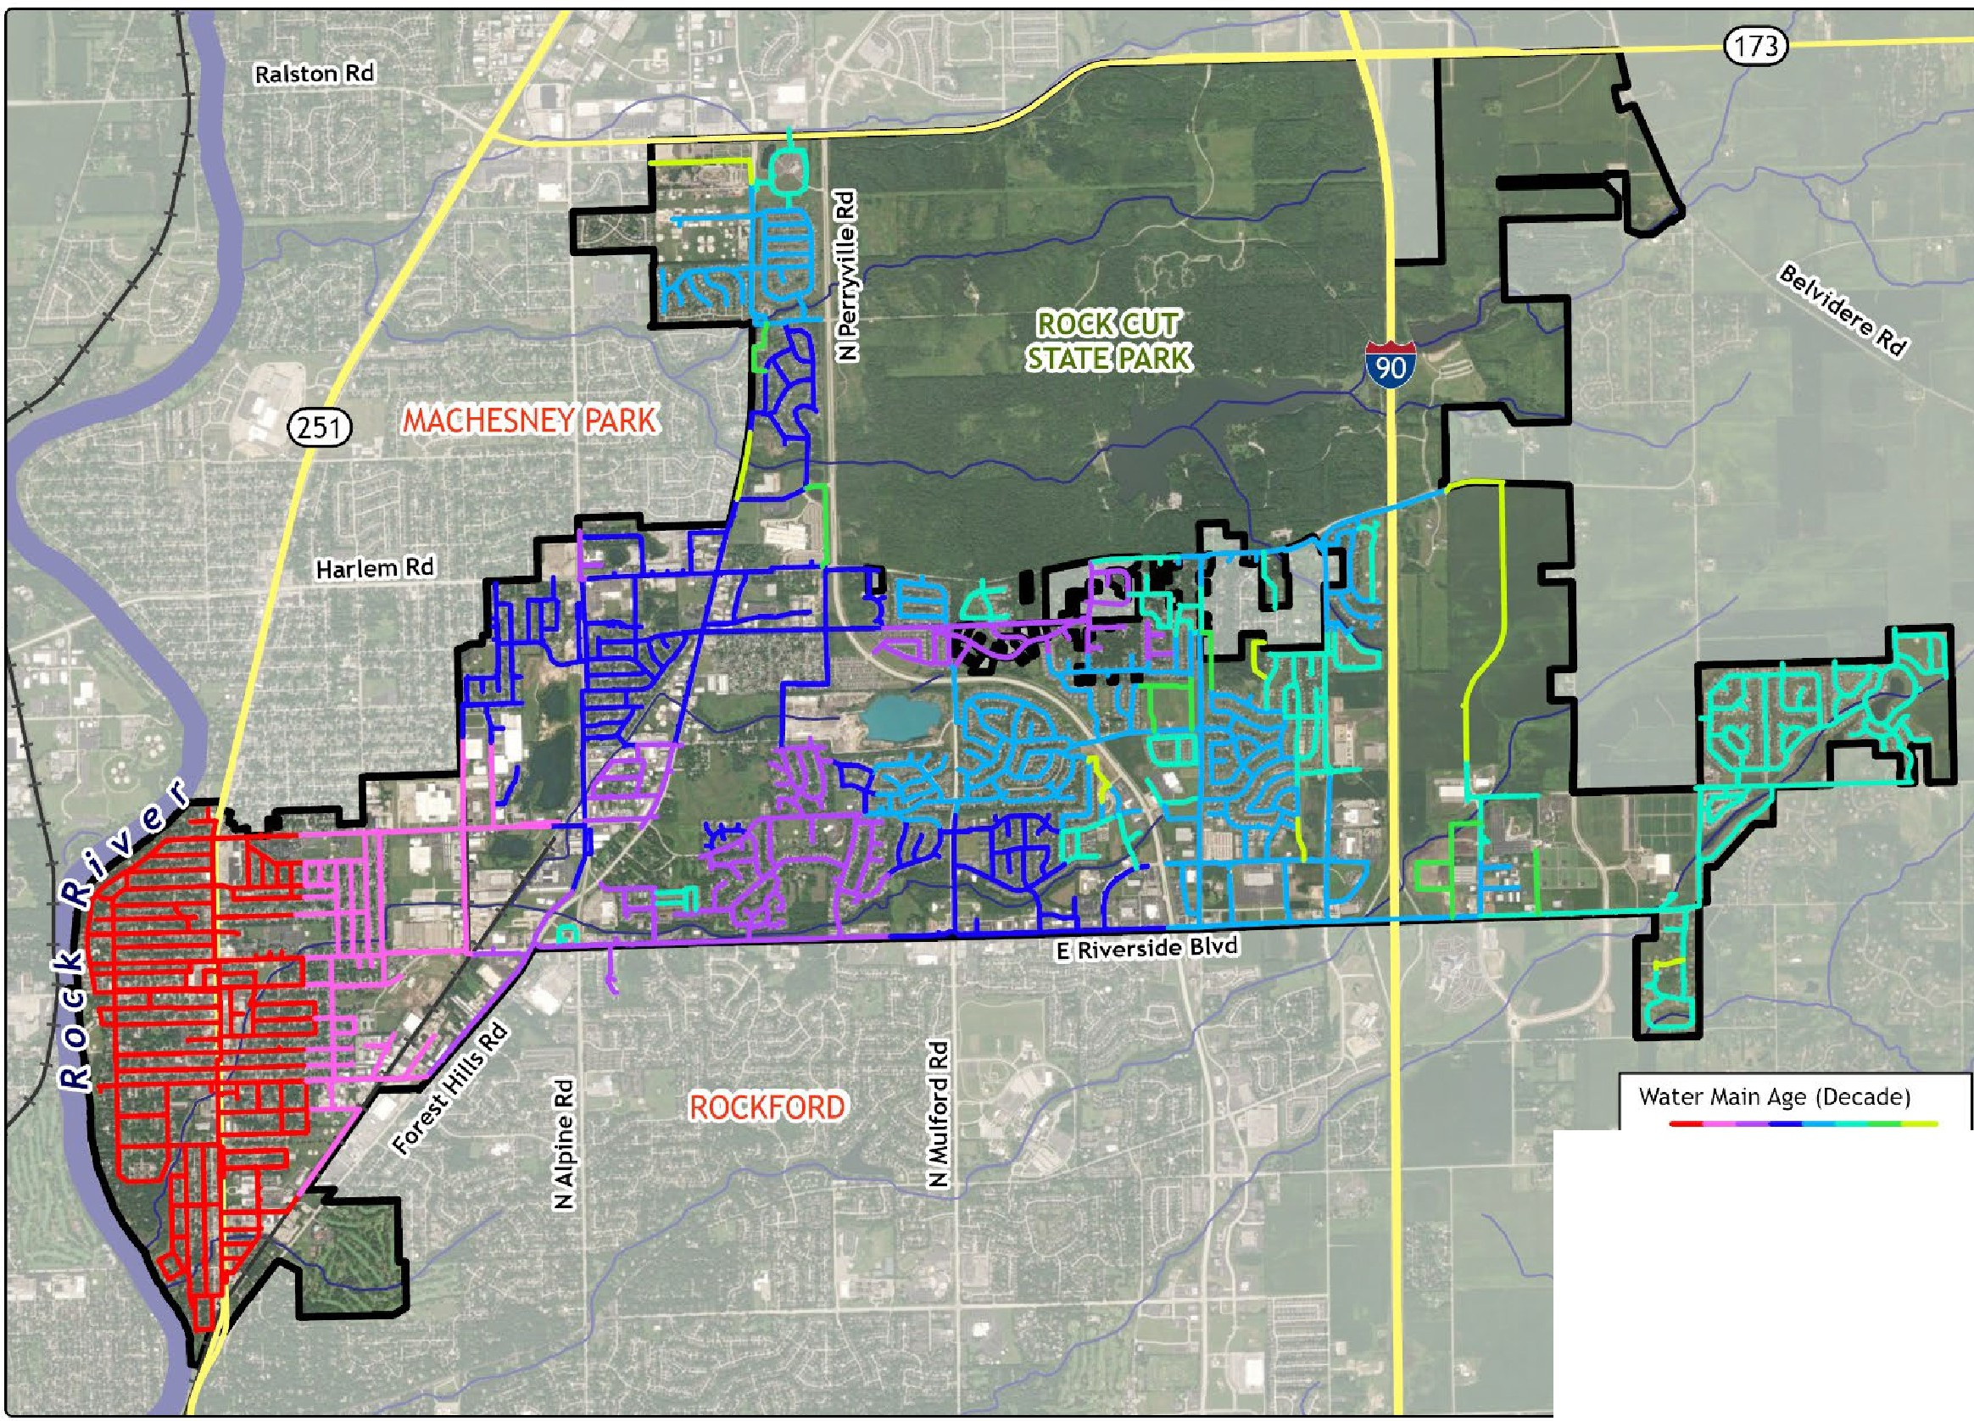

""'""p"''"o"'""'""''"''"_{V}""'"'°''"_{V}'<:>"''"'_{V}<:>""'#'
c::::::I City Limits
Highways
-- NHDPlus• Flow Lines
-+- Railroads
'National Hydrograpt,y Dataset Plus
Figure 2-2: Water Main Age

Material
In the City’s water main network, the material composition of water mains is primarily dominated by ductile iron (DI) and cast iron (CI), which constitute 57% and 39% of the system, respectively. The remaining materials, polyvinyl chloride (PVC) and high-density polyethylene (HDPE), make up less than 5% combined, indicating their minimal use or gradual phasing out in favor of more modern solutions (Table 2-4 and Figure 2-3).

Table 2-4: Material Prioritization Scoring – Weighted 20%
Material | Length (miles) | Percentage of Total System | Score
DI | 74.7 | 57.3% | 0
CI | 51.2 | 39.3% | 2
PVC | 4.3 | 3.3% | 1
HDPE | 0.1 | 0.1% | 1
Notes:
DI: Ductile Iron; CI: Cast Iron; PVC: Polyethylene Chloride; HDPE: High-Density Polyethylene.

Within the approach to prioritizing water main replacement within the City’s system, different materials were assigned scores based on their urgency of replacement and associated risk factors, with this variable weighted at 20% in the overall scoring system. DI has the longest average useful life of the four materials and is the City’s preferred material. PVC and HDPE have similar average useful life lengths, and the City does not have a preference in priority of replacement of one over the other. The City wishes to replace all CI mains in the system, as the material is unreliable.

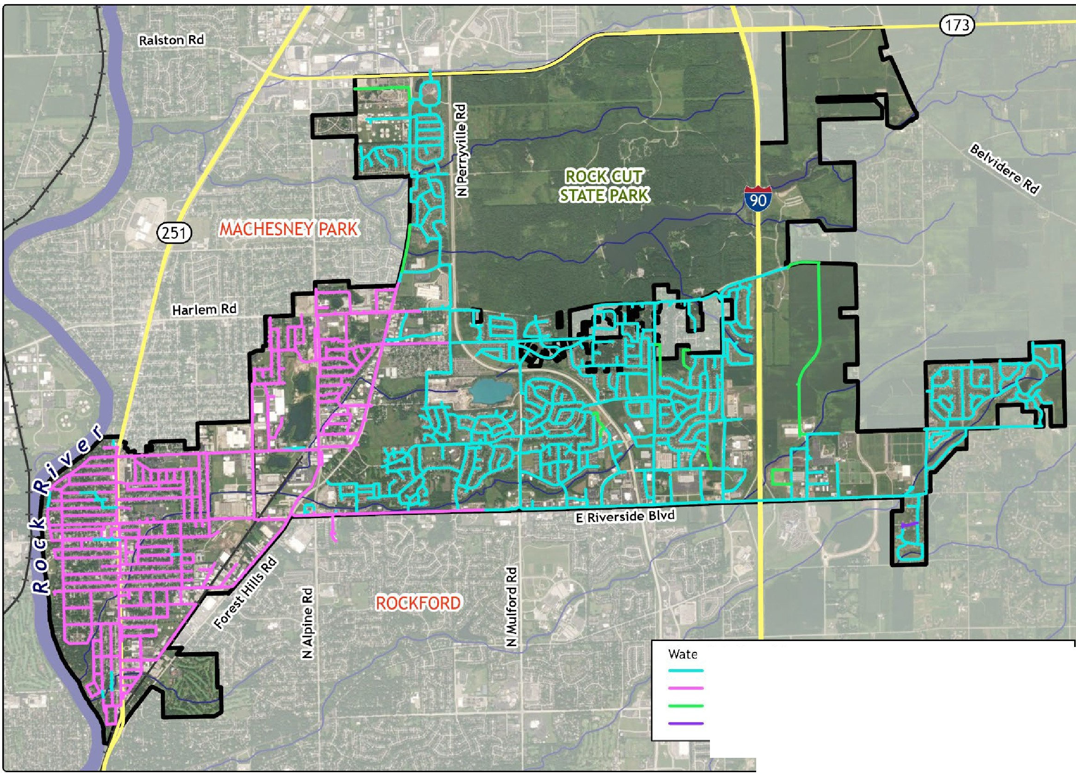
r Main Material Ductile Iron (DI) Cast Iron (Cl)
Polyvinyl Chloride (PVC)
High-Density Polyethylene (HDPE)
c::::::I City Limits
Highways
-- NHDPlus• Flow Lines
-+-
Railroads
'National Hydrograpt,y Dataset Plus
Figure 2-3: Water Main Material

Size
The water main sizes within the network were analyzed to understand the distributions and implications on system performance and maintenance.

As shown in Table 2-5 and Figure 2-4, approximately 42% of the water mains feature an 8-inch diameter, followed by 32% with 6-inch diameters. About 19% of the system has a diameter of 12 inches, and 5% has a diameter of 10 inches. 14-inch and 16-inch diameters are uncommon within the City and make up less than 2% of the system combined.
Less than 1% of the system has a diameter of 4 inches. These mains are already planned to be replaced with 8-inch diameter mains within the next 5 years; therefore, they were treated as 8-inch diameter DI mains installed in the 2020s with no history of breaks and assigned an overall replacement priority score of ‘0’. The individual variable tables and maps provided in this memorandum show the current values and materials of the 4-inch diameter mains and do not account for their planned upcoming replacement.

Table 2-5 provides a detailed breakdown of scores assigned to each water main size.

Table 2-5: Size Prioritization Scoring – Weighted 10%
Diameter (inch) | Length (miles) | Percentage of Total System | Score (Cast Iron) | Score (Other Material)
4 | 1.0 | 0.7% | 0* | 0*
6 | 42.2 | 32.4% | 2 | 2
8 | 54.7 | 42.0% | 0 | 0
10 | 5.9 | 4.5% | 1 | 0
12 | 24.2 | 18.6% | 1 | 0
14 | 0.1 | 0.1% | N/A | 0
16 | 2.3 | 1.7% | N/A | 0
Note: All 4-inch diameter mains are already planned to be replaced with 8-inch diameter mains within the next 5 years.
6-inch diameter mains are generally considered undersized and are not desirable to the City. These mains are the size that the City prioritizes for replacement.

Large CI mains are a concern to the City, as the severity of breaks increases with diameter and CI is the least reliable material in the system, and are prioritized over 8-inch mains of the same material. There are no 14-inch or 16-inch CI mains within the system, so this is only applicable to 10-inch and 12-inch diameter CI mains.

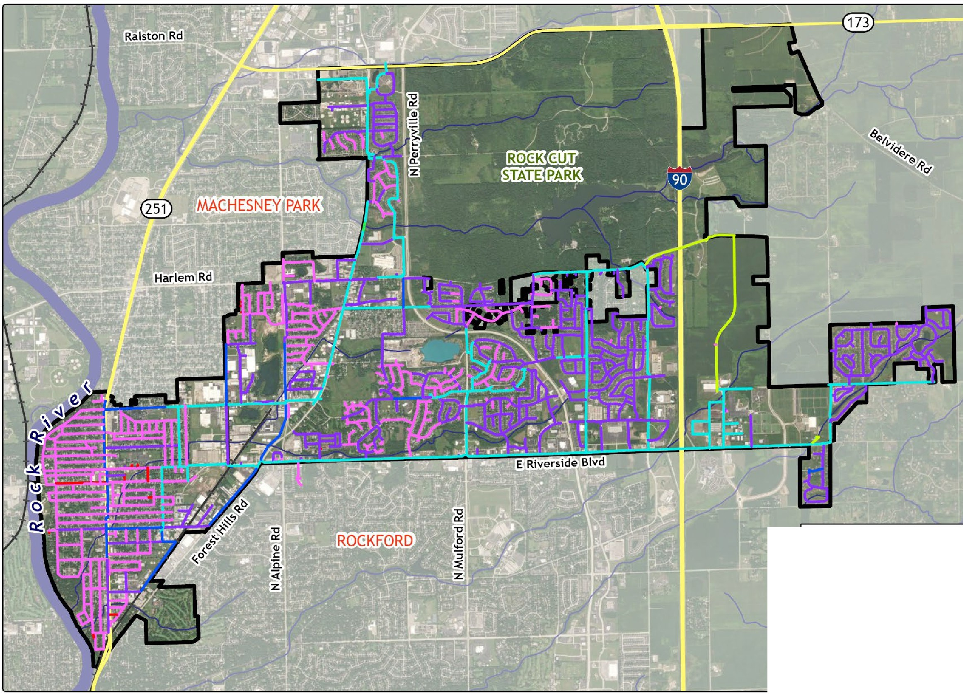

Water Main Diameter

\>. ti -b,6,(\--,f .{. J
c::::::I City Limits
Highways
�- NHDPlus• Flow Lines
-+- Railroads
"National Hydrograpt,y Dataset Plus
Figure 2-4: Water Main Size

GIS Analysis
The Plan analysis was conducted using QGIS version 3.38.1 and ArcGIS Pro version 3.1.0. The following sections summarize the key stages: data review, data processing, and the calculation automation technique.

Data Review and Processing
For the development of the Plan, the City provided two key datasets: a WaterGEMS model of the City’s distribution system and an Excel spreadsheet detailing the break history.
The water main in the WaterGEMS model was exported to a line shapefile that contains data fields for installation year, material, and diameter. The data was thoroughly reviewed, and missing features and fields were flagged and then provided by the City. Installation years were converted to installation decades in a new data field, as most features only had the decade listed.
The break history data needed to be combined with a shapefile to join to the water main shapefile. Each break in the spreadsheet had a location description. Breaks with a street address were joined to an existing address point shapefile. Breaks described by intersections or other non-address locations were manually added to the shapefile. A 50-foot buffer was created around each water main using the ‘Buffer’ tool. Points in the break history shapefile were moved to be closer to the road, within the buffer, and to avoid overlapping multiple buffer features. The ‘Count Overlaps’ tool was then employed to tally the number of breaks within the buffers, and this field was joined to the water main shapefile.

Calculations Automation
The prioritization score calculation for water main replacements was automated using ModelBuilder in ArcGIS Pro. This ensures the scores can be easily updated to reflect any updates in the source shapefile, keeping the assessment current as the water system evolves (Appendix 1: ModelBuilder Configuration for Water Main Replacement Prioritization).
Scores for each category—break history, age, material, and size—were normalized by dividing by their maximum values to equalize the scale across categories. These normalized scores are then weighted and summed according to their importance: 40% for break history, 30% for age, 20% for material, and 10% for size. The formula used is:

𝑅𝑅𝑅𝑅𝑅𝑅𝑅𝑅𝑅𝑅𝑅𝑅𝑅𝑅𝑅𝑅𝑅𝑅𝑅𝑅𝑅𝑅 𝑃𝑃𝑃𝑃𝑃𝑃𝑃𝑃𝑃𝑃𝑃𝑃𝑅𝑅𝑃𝑃 𝑆𝑆𝑅𝑅𝑃𝑃𝑃𝑃𝑅𝑅 = �
𝐶𝐶𝑅𝑅𝑅𝑅𝑅𝑅𝐶𝐶𝑃𝑃𝑃𝑃𝑃𝑃 𝑆𝑆𝑅𝑅𝑃𝑃𝑃𝑃𝑅𝑅 × 𝐶𝐶𝑅𝑅𝑅𝑅𝑅𝑅𝐶𝐶𝑃𝑃𝑃𝑃𝑃𝑃 𝑊𝑊𝑅𝑅𝑃𝑃𝐶𝐶ℎ𝑅𝑅

𝑀𝑀𝑅𝑅𝑀𝑀𝑃𝑃𝑅𝑅𝑀𝑀𝑅𝑅 𝑉𝑉𝑅𝑅𝑅𝑅𝑀𝑀𝑅𝑅 𝑃𝑃𝑅𝑅 𝐶𝐶𝑅𝑅𝑅𝑅𝑅𝑅𝐶𝐶𝑃𝑃𝑃𝑃𝑃𝑃

𝐵𝐵𝑃𝑃𝑅𝑅𝑅𝑅𝐵𝐵 𝑆𝑆𝑅𝑅𝑃𝑃𝑃𝑃𝑅𝑅 × 40
= +
6
𝐴𝐴𝐶𝐶𝑅𝑅 𝑆𝑆𝑅𝑅𝑃𝑃𝑃𝑃𝑅𝑅 × 30 7
𝑀𝑀𝑅𝑅𝑅𝑅𝑅𝑅𝑃𝑃𝑃𝑃𝑅𝑅𝑅𝑅 𝑆𝑆𝑅𝑅𝑃𝑃𝑃𝑃𝑅𝑅 × 20
+
2
𝑆𝑆𝑃𝑃𝑆𝑆𝑅𝑅 𝑆𝑆𝑅𝑅𝑃𝑃𝑃𝑃𝑅𝑅 × 10
+
2

As previously mentioned, the calculator is automated to assign an overall score of ‘0’ to any 4-inch main to reflect their upcoming replacements.

Overall scores were rounded to the nearest integer for convenience, with scores potentially ranging from 0 to 100, with 100 indicating that a water main is the highest priority for replacement, directing resources efficiently to the network segments that most urgently require attention.

Prioritization Breakdown
Based on an analysis of the water main remaining useful life distribution, approximately 19% of the system has no remaining useful life. Additional mains run out of their useful life at a relatively even slope up to 2055. From 2055 to 2090, the rate at which the system loses its remaining useful life slowly increases. By 2100, over 95% of the current system is projected to have no remaining useful life.
The system has been broken into three categories of approximately equal intervals: high, medium, and low. As a result, the water mains are categorized as follows: 38.9% high risk, 40.2% medium risk, and 20.9% low risk. This approach allows for replacement efforts to be focused on areas with the greatest need due to the increased likelihood of failure.
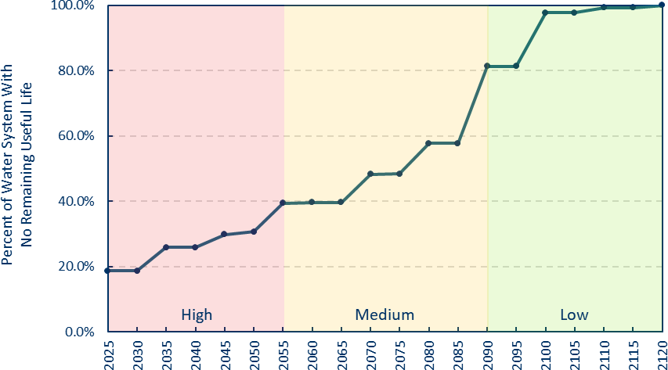
Figure 2-5: Percent of Water System with No Remaining Useful Life

FINDINGS
Prioritization Scores
Results of the prioritization calculations showed that the City’s water main scores ranged from 0 to 100. Figure 3-1 categorizes the water mains into three groups—low, medium, and high priority—based on their calculated scores and the analysis of the remaining useful life distribution. The total lengths for each category are as follows: low priority (0-10) with 27.2 miles, medium priority (11-39) with 52.4 miles, and high priority (40-100) with 50.7 miles.
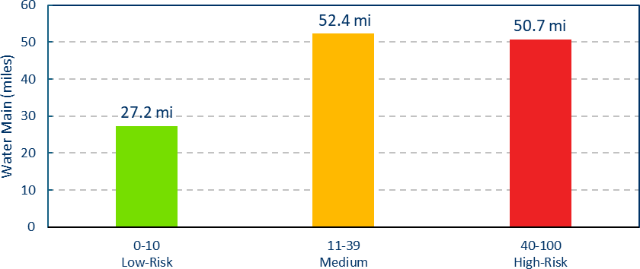
Figure 3-1: Replacement Prioritization Categories by Length

Figure 3-2 further elaborates on the distribution of replacement scores throughout the water system, emphasizing the specific categories discussed in Figure 3-1. This distribution is pivotal in identifying high- risk areas that require immediate attention.

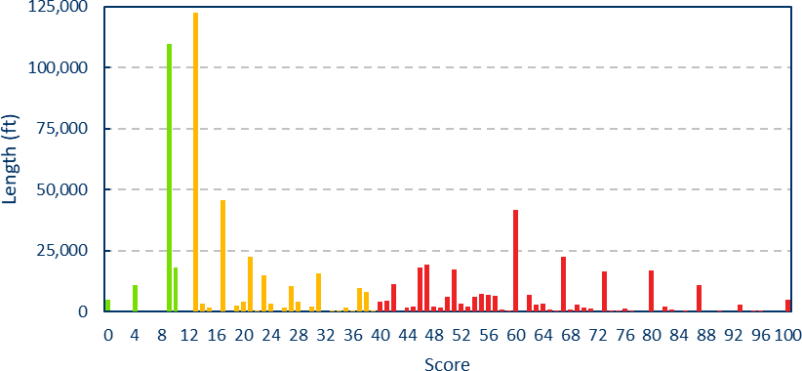
Figure 3-2: Replacement Prioritization Scores by Length

Geographic Trends
Geographic analysis reveals that the mains with the highest priority scores are on the west side of the City, especially west of Forest Hills Road. These areas are likely to benefit most from targeted water main replacements due to their degraded conditions. Scores are the lowest at the northern and eastern edges of the system.

Many of the four variables are correlated. The newer parts of the system are more likely to be ductile iron or PVC. These areas have very few past breaks because of their relative age. Most CI mains are over 35 years old and account for the majority of the past breaks within the system.

July 30, 2025
Loves Park Limited Water Main Replacement Master Plan Page 16

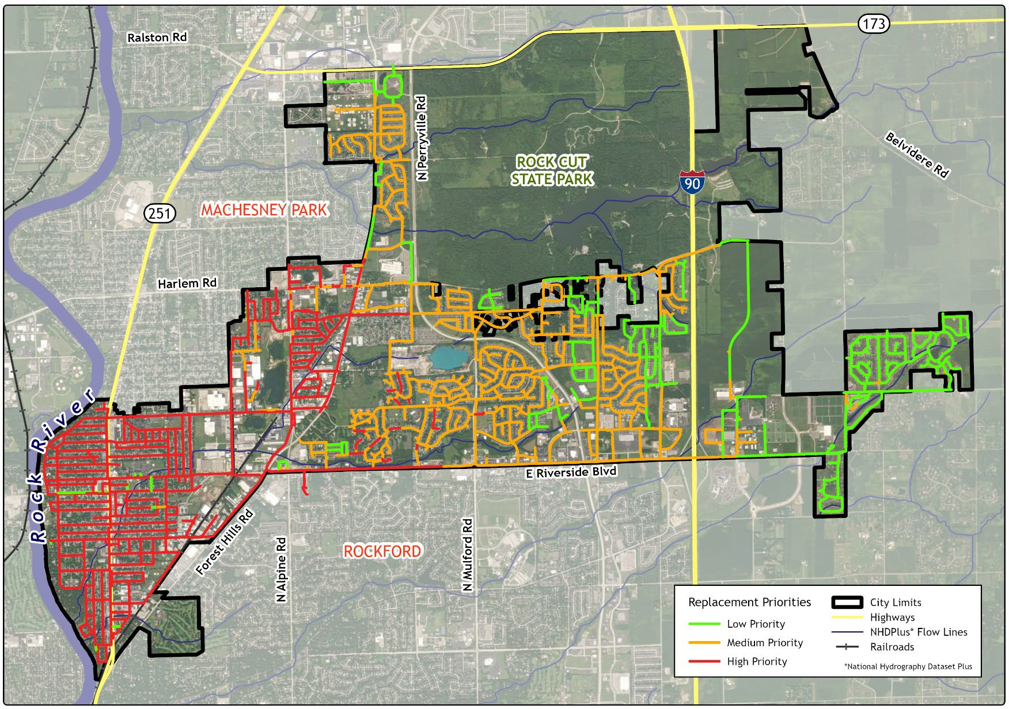
Figure 3-3: Water Main Replacement Priorities

RECOMMENDATIONS
To optimize the water main replacement for the Loves Park system, recommendations are provided based on cost analysis, geographic priorities, and system-wide assessment.

Replacement Rate
Municipal water systems often aim for a replacement rate that cycles through their entire infrastructure every 100 years, replacing approximately 1% of the system annually. This recommendation is a widely accepted industry practice, aligning with the typical 100-year lifespan expected for water mains (Meyers et al., 2020). However, if Loves Park follows a 1% replacement rate, the system would be left vulnerable, as the mains reach no remaining useful life faster than they are being replaced (Figure 4-1). Therefore, it is recommended that the City follow a more proactive approach of a 1.30% replacement rate annually, equating to 1.69 miles of water main per year. This adjusted rate ensures that all high-risk mains (scored 40 or higher) are replaced within the next 35 years.
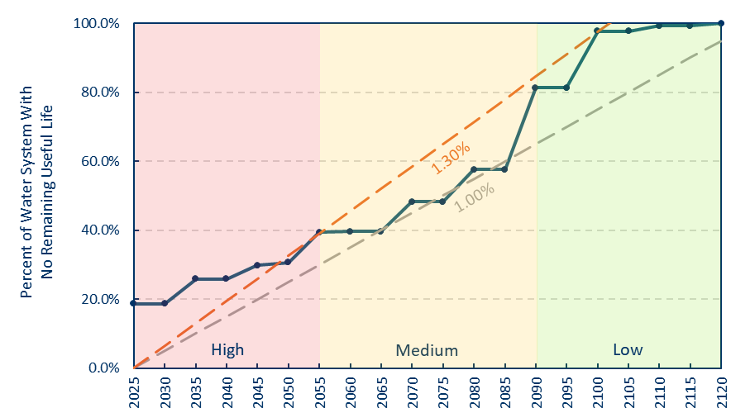

Figure 4-1: Projected Percentage of Water System with No Remaining Useful Life Under Different Replacement Rates
Budget Estimates
Cost estimates were developed at 0.5-mile increments for different pipe diameters based on recent bid sheets from surrounding communities and professional experience, ensuring the calculations would be applicable across various scenarios within the City’s system. These cost estimates should be viewed as a rough approximation, providing a baseline for planning purposes rather than precise figures.
The estimates were based on several key assumptions and involved ancillary and actual pipe costs.

Ancillary Costs
The ancillary costs associated with the water main replacement included a range of essential activities, ensuring proper infrastructure installation and restoration. These include trenching and aggregating base placement, which provides a stable foundation for the new water main. They also include installing valves and hydrants, which are crucial for system functionality and emergency access. Asphalt placement, sidewalk, and curb restoration are required to ensure that roadways are fully repaired after installing the water main and services, maintaining the affected areas’ infrastructure and appearance.
Ancillary costs included service connections to link the new mains with the existing properties, general site restoration landscaping, and other surface repairs. Mobilization covers the costs of bringing necessary equipment and materials to the site. Table 4-1 provides a summary of the ancillary costs and assumptions estimated per 0.5 mile of replacement.
Table 4-2: Ancillary Costs for Water Main Replacement (Per 0.5 Mile)
Item | Assumption | Unit | Quantity | Unit Price | Total Price
10' Wide Trench, 12" Thick Aggregate Base Course | Placed in square yards | SY | 2,933 | $30 | $88,000
90' Lots with Service on | 60 lots | EA | 60 | $3,000 | $180,000
Valves | 1 per 300 feet | EA | 9 | $4,500 | $40,500
Hydrants | 1 per 300 feet | EA | 9 | $10,000 | $90,000
Asphalt Placement | 4" thick, 10' wide trench | Tons | 657 | $120 | $78,848
Curb on One Side of Road | Lineal foot | LF | 2,640 | $45 | $118,800
Sidewalk for Each Service | 10' wide trench, 5' | SF | 3,000 | $20 | $60,000
Water Main Connections | 2 per 500 feet | EA | 10 | $9,500 | $95,000
Restoration | General site restoration | LS | 1 | $25,000 | $25,000
Mobilization | Project mobilization | LS | 1 | $40,000 | $40,000
Total |  |  |  |  | $816,148
Notes: SY: square yards; EA: each (used to quantify individual items); LF: linear foot; SF: square foot; LS: lump sum (a single, total price for an item, regardless of the quantity). This approach assumes that water main must be placed within the limits of the roadway and cannot be placed in the parkway to avoid pavement replacement costs.

Pipe Costs
The second portion of the cost estimate for the water main replacement is based on the pipe diameter, calculated on a per-linear-foot basis. The costs vary by pipe size, with smaller diameters being less expensive to install. The budget estimates are specifically focused on replacing high-risk pipes. Of these high-risk pipes, 77% require replacement with 8-inch pipes, 10% with 10-inch pipes, and 13% with 12- inch pipes. The estimated cost per linear foot is $200 for an 8-inch pipe, $225 for a 10-inch pipe, and
$250 for a 12-inch pipe. The final cost per linear foot, which includes ancillary costs, was calculated by adding these base pipe installation costs to additional expenses outlined earlier, providing a comprehensive estimate for the entire project (Table 4-2 and Figure 4-2).

Table 4-3: Total Cost for 0.5-Mile Water Main Installation by Diameter
Diameter | Unit | Unit Price | Price | Total w/ Ancillaries ($/LF)
8" | LF | $200 | $528,000 | $510
10" | LF | $225 | $594,000 | $535
12" | LF | $250 | $660,000 | $560
Notes: LF: linear foot.

$600
$510
$535
$560

$550
Cost per Linear Foot

$500

$450
8" 10" 12"
Figure 4-1: Total Cost per Linear Foot by Pipe Diameter
(Including Ancillary Costs)

Phased Implementation Strategy
The phased implementation strategy for the Loves Park water main replacement is designed to tackle the most critical infrastructure needs first, ensuring a systematic and efficient replacement of the aging water mains while minimizing disruptions to the system and the community. This strategy breaks down the replacement into six distinct phases, allowing the City to manage resources effectively, adjust plans as necessary, and ensure continuous service.
To arrive at the cost estimates for each phase, the calculations were simplified by first determining the percentage of the total length of each pipe diameter within the high-risk category. This total was then used to estimate the cost of replacing the entire high-risk system, which was then divided evenly across the five phases. To account for inflation, a 4% annual increase was included in the calculations. Below is a breakdown of the phased implementation plan (Table 4-3). It is recommended to update the Master Plan every five years for cost calibration and outlook for rate analysis purposes.

Table 4-3: Phased Water Main Replacement Summary (2026-2055)
Phase | Years | Miles Replaced | Total Cost
Phase 1 | 2026-2030 | 8.468 | $ 25,017,100
Phase 2 | 2031-2035 | 8.468 | $ 29,650,000
Phase 3 | 2036-2040 | 8.468 | $ 34,282,700
Phase 4 | 2041-2045 | 8.468 | $ 38,915,500
Phase 5 | 2046-2050 | 8.468 | $ 43,548,800
Phase 6 | 2051-2055 | 8.468 | $ 48,181,100
Total | 2026-2055 | 50.81 | $ 171,413,700

REFERENCES
Meyers, R., LeBrun, M., & Kettler, A. (2020). Water main break rates in the USA and Canada: A comprehensive study. Utah State University. https://digitalcommons.usu.edu/cgi/viewcontent.cgi?article=1681&context=water_rep

Appendix 1: ModelBuilder Configuration for Water Main Replacement Prioritization

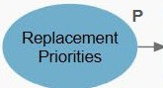
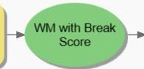
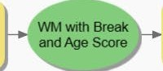
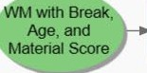
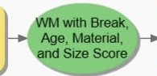
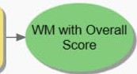
Break History Score
Age Score
Material Score
Size Score
Overall Score

